Saving America’s Alliances

The United States Still Needs the System That Put It on Top

By Mira Rapp-Hooper
March/April 2020

In his three years in office, U.S. President Donald Trump has aimed his trademark vitriol at a wide range of targets, both foreign and domestic. Perhaps the most consequential of these is the United States’ 70-year-old alliance system. The 45th president has balked at upholding the country’s NATO commitments, demanded massive increases in defense spending from such long-standing allies as Japan and South Korea, and suggested that underpaying allies should be left to fight their own wars with shared adversaries. Trump’s ire has been so relentless and damaging that U.S. allies in Asia and Europe now question the United States’ ability to restore itself as a credible security guarantor, even after a different president is in the White House.
But the tattered state of the alliance system is not Trump’s doing alone. After decades of triumph, the United States’ alliances have become victims of their own steady success and are now in peril. In the early years of the Cold War, the United States created the alliance system to establish and preserve the balance of power in Asia and Europe. To adapt the phrase of the commentator Walter Lippmann, alliances became the shields of the republic. These pacts and partnerships preserved an uneasy peace among the major industrialized countries until the end of the twentieth century. And they came with far fewer financial and political costs than Trump and some international relations scholars have claimed. When the Soviet Union collapsed, American policymakers wisely preserved this trusty tool of statecraft. But because the United States had no real peer competitors, the alliance system was repurposed for a world of American primacy and lost its focus on defense and deterrence.
Nearly 30 years later, an undeniably powerful China and a revanchist Russia have developed military and nonmilitary strategies that seek to unravel the system entirely. Trump’s antagonistic instincts are certainly destructive, but the changing nature of conflict is the true hazard. Faced with cyberattacks, disinformation campaigns, economic coercion, and more, Washington needs its alliance system to preserve order. If the pacts are to be saved, however, they must be renovated for the world they confront: one in which most threats to security and prosperity pass just below the military threshold.

A BRAVE NEW WORLD
World War II transformed the scope and lethality of conflict. The United States had long benefited from its relatively isolated geographic location, but the spread of long-range airpower, missile technology, and nuclear weapons meant that its security was no longer guaranteed. Newly exposed, the United States sought a strategy that would allow it to secure the international balance of power from afar, averting conflicts on its territory and preventing the only other superpower left standing after the war, the Soviet Union, from dominating Asia and Europe. The United States created a network of alliances precisely with these goals in mind. U.S. policymakers reasoned that by acquiring allies and building overseas bases on those countries’ territory, Washington would be able to confront crises before they reached the homeland. What’s more, with this forceful presence, the United States could practice so-called extended deterrence, dissuading adversaries from starting wars in the first place.
Unlike the alliance systems of the past, the U.S. system was intended to prosecute or deter not a single war but all wars, and to do so indefinitely. The novelty—and the gamble—was that if the new security system worked, the world would see little evidence of its power. This new approach was a radical departure from the pre–Cold War norm, when the United States considered itself largely self-sufficient and pursued few foreign entanglements; it had no formal allies between the Revolutionary War and World War II. Between 1949 and 1955, in contrast, the United States extended security guarantees to 23 countries in Asia and Europe. By the end of the twentieth century, it had alliances with 37.
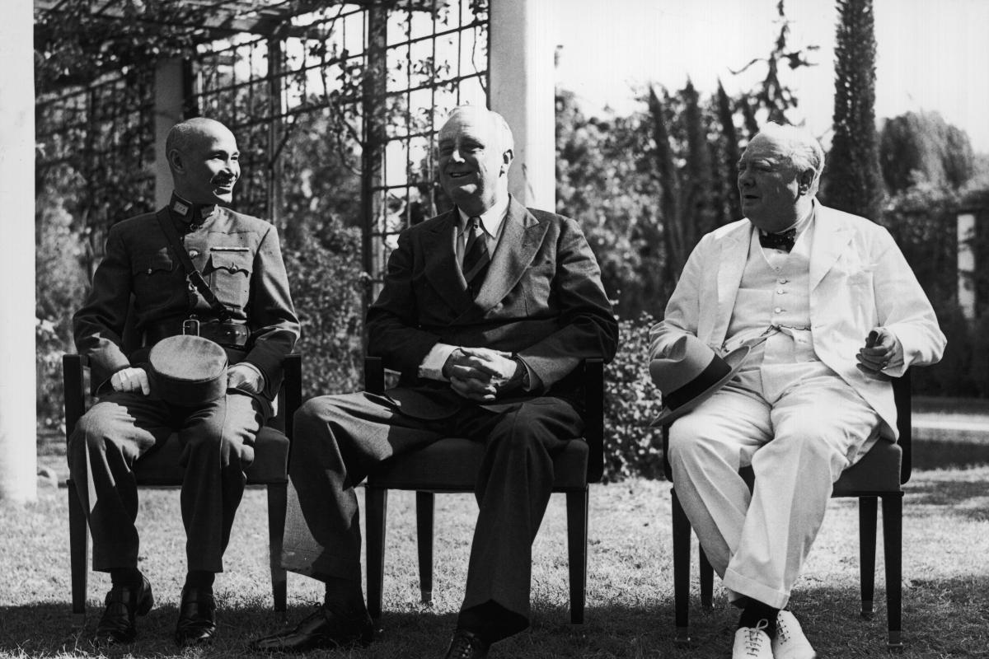
Chiang Kai-shek, U.S. President Franklin Roosevelt, and British Prime Minister Winston Churchill in Cairo, November 1943
IWM / Camera Press / Redux
The United States’ Cold War alliances were successful in meeting the goals that strategists had set out for them. For the duration of the Cold War, no U.S. treaty ally was ever the victim of a major attack. And until the 9/11 attacks, no NATO member had ever invoked the treaty’s Article 5 guarantee, which obligates the allies to assist any member state that comes under assault. Of course, Washington had intervened at times to support allies in a fix—helping Taiwan manage Chinese aggression during two crises in 1954–55 and 1958, for example—but it did so chiefly when it saw its own interests at risk and often with the explicit aim of preventing war. In addition to maintaining the balance of power in Asia and Europe, the system contributed to the flourishing of the United States’ allies, most notably Japan and West Germany, which became close military partners, consolidated themselves as democracies with vibrant economies, and eventually emerged as leading regional powers.
The alliance system also lowered the cost of U.S. military and political action worldwide. Since the early 1950s, U.S. treaty allies have joined every major war the United States has fought, despite the fact that for almost all these conflicts, they were not required to do so by the terms of their alliances. What’s more, the system ensured that the allies’ foreign policies supported, rather than undermined, Washington’s. The United States used security guarantees to convince South Korea, Taiwan, and West Germany to abandon illicit programs to develop their own nuclear weapons. Other states that, if they had not been included in U.S. alliances, would surely have sought their own military protection—building state-of-the-art armies, navies, and air forces—chose instead to rely on the United States’ military might. And by maintaining close defense relationships with a number of those states, the United States also gained support in international institutions for everything from peacekeeping missions to sanctions—support that would otherwise have been much harder to secure. These contributions were crucial, as they allowed the United States to project its power without becoming overstretched.

LONELY AT THE TOP
The alliance system continued to function smoothly until 1991, when the adversary for which the United States’ entire security posture had been designed suddenly disintegrated. The Soviet Union vanished, and with it, so did the logic of American security guarantees. Notable international relations scholars—primarily those of a realist orientation—believed that in a unipolar world, U.S. alliances had become outmoded. But U.S. policymakers were unpersuaded. The Cold War system had performed so admirably that they decided it should be retained and repurposed for new objectives. Because the United States was now utterly unmatched in its military and political power, however, their alliance reforms did not focus on defense or deterrence as traditionally understood.
U.S. President Bill Clinton’s administration supported the entry of former Eastern-bloc states (such as the Czech Republic, Hungary, and Poland) into NATO in the belief that an expanded Atlantic alliance would help spread democracy and promote stability in post-Soviet eastern Europe—an urgent task given the humanitarian crisis that seized the Balkans with the breakup of Yugoslavia in 1991 and 1992. In other words, Clinton decided to expand the alliance in the aftermath of the Cold War rather than dismantle it. Far from treating Russia as a vanquished adversary, his administration sought to gain Moscow’s acquiescence to NATO enlargement. And through the Partnership for Peace—a NATO-backed military-cooperation program designed to build trust with post-Soviet states without officially including them in the alliance—Clinton sought to give eastern European countries ways to associate with NATO without spooking the Russians. For most of the 1990s, as the alliance pushed eastward, this approach appeared to be working: in private, Russian officials even floated the idea that their country might someday join NATO.
But by extending NATO to the Baltic states—Estonia, Latvia, and Lithuania—in 2004, U.S. military planners inadvertently made the alliance much harder to defend. Russia still sought a buffer zone that would keep it safe from western Europe and the United States and saw the countries on its western border as its first line of defense. The United States’ old rival, preoccupied by its failing economy, was not deeply troubled by the earlier rounds of NATO expansion. But the situation quickly changed after the Baltic states entered the alliance. Russia invaded Georgia in 2008 and Ukraine in 2014 to ensure that neither country would join NATO. Along the way, it developed a military strategy designed to demonstrate the United States’ inability to defend the Baltics, relying on the prospect of a rapid invasion that would leave Washington with the painful choice between escalation and surrender.
Trump’s alliance shakedown is almost certain to backfire.
In the meantime, an ascendant China has sought to corrode U.S. alliances in the Pacific. Beginning in the early 1990s, Beijing has invested in missiles and other military technology that would deter the United States from intervening in a conflict close to China’s shores—namely, one over Taiwan. By making it costlier for Washington to enter a war, China’s leaders have attempted to undermine U.S. security guarantees and demonstrate to U.S. allies in the Pacific that the United States’ ability to protect them is waning. After years of dizzying growth that fueled huge increases in military spending, Chinese President Xi Jinping has set his sights higher than his predecessors, seeking to reestablish China as a great power.
Beijing and Moscow have also developed nonmilitary means—economic coercion, cyberwarfare, and political interference—to advance their objectives. China and Russia use these tactics in very different ways, but the underlying logic is the same: to achieve their goals without activating U.S. security guarantees or violating laws against the use of force. In 2007, for instance, Russian cyberattacks paralyzed Estonia, taking down bank and government websites. And between 2014 and 2016, China initiated a massive island-building campaign in the South China Sea, transforming former reefs and rocks into military bases, upending the balance of power, and threatening U.S. allies—namely, the Philippines. In both cases, the transgressions undermined the security of U.S. treaty partners and demonstrated that the pacts were powerless to stop nonmilitary aggression.
To make matters worse, the Trump administration is deeply critical of NATO members and other U.S. allies, a hostility that acts as an accelerant to the geopolitical forces that were already weakening the system of pacts. Unlike previous presidents, who privately pressed U.S. allies to contribute more to the security relationship, Trump engages in the public and arbitrary coercion of U.S. allies, making extravagant spending demands and stating that the United States will abandon them if they do not pay up. (Asked if the United States would defend the Baltics against a Russian attack, for example, Trump replied, “If they fulfill their obligations to us.”) In general, Trump views the protection of the American homeland as his near-exclusive national security objective and places little value on the U.S. military presence abroad, instead fixating on border security. This view is at odds with the United States’ long-standing reliance on forward defense and deterrence, which was based on the belief that the homeland is best protected through a network of alliances and overseas bases that keep war from starting.
Trump’s alliance shakedown is almost certain to backfire. Some of the costs are already on display: South Korea, for instance, has tilted toward China by using diplomacy to mend previously strained ties and to establish military hotlines. Meanwhile, French President Emmanuel Macron has bemoaned the “brain death” of NATO, and German Chancellor Angela Merkel has questioned whether U.S. allies can trust the United States. If U.S. allies do eventually devote more to defense because of slackened American leadership, they are likely to do so in ways disadvantageous to the United States, spending more on independent forces and strategies rather than assuming protection from and partnership with the United States. U.S. interests may fall by the wayside as a result. For instance, the Trump administration has declared competition with China to be the United States’ highest national security priority, and leaders in both political parties agree that the challenge is momentous. To date, however, Washington has found little support among its allies for its campaign against Beijing. The United States can steady the shifting twenty-first-century balance of power only in tandem with its allies in Asia and Europe. Otherwise, it will be a feeble and lonely competition, indeed.

THE PRICE OF POWER
Both the Trump administration and notable international relations scholars worry that the United States’ alliances lead to chronic free-riding, allowing U.S. allies to benefit from American security guarantees and military cooperation even though they add comparatively little to the relationship. Nearly every U.S. president has wished that the country’s allies would spend more on defense, and there is little doubt that the United States has generally outspent most of its treaty allies in Asia and Europe. The imbalance persists even today: the United States spends over three percent of its GDP on defense; the next-highest spenders among the United States’ allies spend 2.5 percent, and many others spend 1.5–2.0 percent. But these numbers are deceptive. The United States, after all, maintains a global defense posture, whereas its partners generally spend on security in their immediate neighborhoods. What’s more, U.S. military spending in such countries as Germany and Japan is largely devoted to a regional defense strategy, as opposed to the defense of a single host ally. There is no reason to expect those countries’ defense budgets to be comparable to that of the United States.
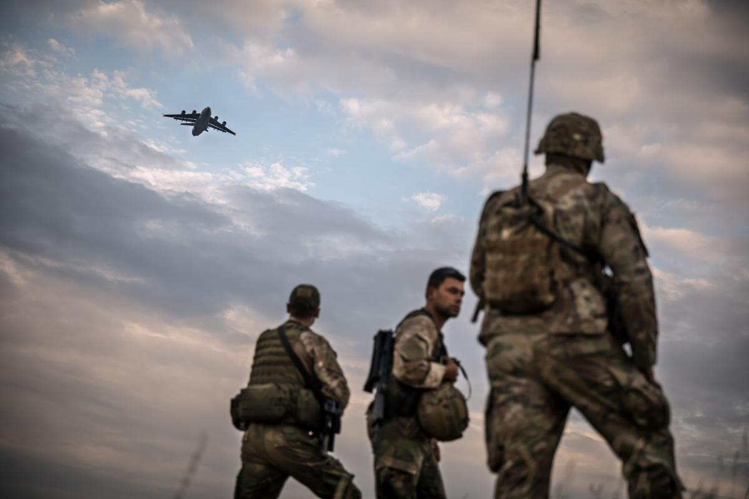
U.S. soldiers at a NATO military exercise in Bulgaria, July 2017
Gordon Welters / laif / Redux
U.S. allies also contribute to their alliances with the United States in ways that aren’t captured by their defense expenditures—such as by granting low-cost leases for U.S. bases and constructing facilities for use by U.S. troops. Contrary to common perceptions, alliances themselves cost nothing: it is the spending on deployments and infrastructure that results in high costs. And Washington’s allies often assume part of the burden. Moreover, the price of the American alliance system has, historically, been an acceptable portion of the U.S. national budget. There is little evidence that alliance-related spending has forced other major tradeoffs or has been a drag on economic growth. And the asymmetry between Washington’s spending and that of its allies is a feature of the alliance system, not a bug: it gives the United States more influence over its partners, who depend on American strength for their security.
There is also relatively little evidence that the United States’ alliances have imposed major political costs. International relations scholars often fret about “alliance entrapment,” which would occur if the United States intervened in crises or conflicts that it might have ignored if it did not have obligations to another state. Yet there is almost no proof of that phenomenon. U.S. allies are no more likely to become involved in conflicts than other states, and although the United States has waged some ill-advised wars—such as the Vietnam War and the Iraq war—no ally was responsible for those decisions. Instead, when Washington has backed its allies in crises, it has done so because it has also had a clear national interest at stake. Moreover, the United States has never found itself in an alliance arrangement that it was unable to exit. In the few cases in which alliances became politically inconvenient, as with the underperforming Southeast Asia Treaty Organization, Washington was able to disentangle itself easily.
Entrapment is uncommon because the United States designed its alliance system to reduce its exposure to risky commitments. Take Taiwan, for instance. In 1955, the United States allied with Chiang Kai-shek, the brash Taiwanese president who still hoped to retake the Chinese mainland. In their negotiations with Chiang over the alliance, U.S. officials took special care to impress on him that he did not have U.S. backing to attack the People’s Republic of China, and they made clear that the treaty they were to sign with him did not apply to the offshore islands that were still in dispute between Taiwan and China. So in 1958, when the two came to loggerheads over those same islands, the United States had the freedom to support its ally only as it saw fit—in this case, by offering diplomatic support and by helping supply the islands. Washington has also been selective in its choice of partners, rejecting requests for security pacts when the associated commitments were too dangerous. Despite a close relationship, the United States has declined to extend formal security guarantees to Israel, for example, calculating that the risk of an unwanted war is too high.
The United States has never found itself in an alliance arrangement that it was unable to exit.
It is no easier to find examples of U.S. allies that have reneged on their commitments to Washington. From the formation of the alliance system until the 9/11 attacks, neither the United States nor any of its partners had been the victim of an unprovoked assault, so there have ultimately been few opportunities for an ally to jilt Washington on the brink of a conflict. This is not to say that the United States has never faced downsides from its alliance system. Chronic, if modest, allied free-riding on U.S. defense spending is surely an annoyance. On rare occasions, moreover, an ally has reneged on its commitments in costlier ways, as French President Charles de Gaulle did when he pulled France out of NATO’s military structure but not the alliance altogether. And once the alliance system was put in place, it may have encouraged the United States to define its security needs more expansively than it might have without the pacts. Nevertheless, the system’s drawbacks have been far fewer, both in number and in intensity, than some scholars and policymakers would have people believe.

RECALIBRATING ALLIANCES
Despite the U.S. alliance system’s manageable cost and incredible success, the United States’ ties to its allies are under more scrutiny now than at any time in recent memory. The American public remains broadly supportive of international coalitions, yet for the first time since World War II, U.S. alliances have become deeply politicized. Although foreign policy experts from both political parties defend the system, the Trump administration’s core supporters abhor it. With Congress and the public polarized on all manner of issues, the country’s alliances could remain objects of controversy even under new leadership.
International forces have not been any kinder to the postwar alliance system. In Asia, relative power is shifting in China’s favor. Russia is stagnant but remains a force to be reckoned with. And overall, the United States and its allies together hold a smaller share of global GDP and military spending than they did at the end of the Cold War. Nevertheless, they also have highly developed, technologically sophisticated economies, and their combined defense spending dwarfs that of their rivals. This all suggests that the United States can salvage its wildly successful but badly bruised alliance system, so long as it does so on entirely new terms.
The United States’ ties to its allies are under more scrutiny now than at any time in recent memory.
Over the second half of the twentieth century, the nature of conflict changed dramatically. The spread of nuclear weapons and the growth of economic interdependence raised the cost of great-power war to such heights that challengers now seek to avoid it. Although it remains possible that U.S. allies will face major military attacks, this is not terribly likely. China and Russia prefer nonmilitary coercion that will not trigger NATO’s Article 5 guarantee. But the United States and its allies need not wait for the United Nations or any other international body to sanction new forms of collective self-defense. International law already allows them to fashion joint responses to actions deemed threatening to their political independence—the very sorts of injuries that result from cyberattacks, election meddling, and extreme economic pressure. Washington and its partners have all the power they need to reform the system, but to succeed, they will have to focus on the challenges to security and prosperity that stop just short of the military threshold.
The United States and its allies must start by rebalancing their respective responsibilities. Although Washington’s alliance strategy was affordable during the Cold War, the Trump administration’s heavy-handed demand that U.S. allies assume greater costs does contain a kernel of sanity. When the treaty system was formed, the United States’ main allies were war-torn states teetering on the brink of collapse. They are now thriving democracies with developed economies capable of contributing to a more symmetric defense effort. Many U.S. allies have trouble increasing their defense budgets for domestic political reasons—their citizens are accustomed to relatively low defense spending and resist budget hikes. The allies can, however, contribute to nonmilitary defense and deterrence, as most of this spending does not show up in military budgets; rather, it appears on foreign affairs, intelligence, and homeland security ledgers. Moreover, compared with the United States’ rivals, American treaty allies are leaders in covert information gathering, public diplomacy, and technological research and development. They can also spend more easily in these areas. Like them, the United States will need to reorganize its security expenditures, spending less on the military in favor of the nondefense national security tools necessary to lead alliances.
Even so, the United States will need to keep primary responsibility for high-end military defense, as its allies focus on other missions. Now that the Baltic states are firmly ensconced in NATO, Washington will have to guide its partners toward their credible defense. In particular, NATO allies must improve their military readiness and deter Russian aggression by demonstrating their ability to quickly reach and secure NATO’s eastern flank. The military picture in Asia is far more urgent: U.S. partners will have no chance of countering China’s growing power without American assistance. Asia must therefore be the United States’ primary military theater, with Europe an important but clear second. U.S. spending and presence should reflect those priorities, with more dollars spent on platforms that are intended to deter China and more deployments directed toward the western Pacific.
Despite continued security guarantees, U.S. allies must take primary responsibility for lower-end defense and deterrence. This is only appropriate: China and Russia each use coercion to the greatest effect in their immediate neighborhoods, so such geographically exposed allies as Japan and the Baltics are the frontline states at greatest risk. U.S. allies must assume financial and political leadership roles that place them in charge of specific countercoercion efforts. And they must take the lead in crafting responses that are tailored to their specific needs. After Estonia became the victim of a massive cyberattack allegedly carried out by Russia, for example, it expanded its capabilities in cyberspace and pioneered resilience efforts that will blunt the power of Moscow’s cyberwarfare in the future.
Equipment for a NATO cyberdefense exercise in Tallinn, Estonia, April 2019
Ints Kalnins / Reuters
But the allies must go further than self-defense: they must devise regional responses to the threats in their respective parts of the world. Australia and Japan, for example, should build up the allies’ capabilities in Southeast Asia, to ensure that the assistance that they and the United States give to China’s maritime counterclaimants is used efficiently and effectively. And because security issues are no longer clearly bounded by geography, U.S. allies should set up cross-regional working groups to address questions that affect them all, such as cyberthreats and foreign investment. The United States should remain an enthusiastic participant in and contributor to these efforts, but the choice of strategies and the development of alliance infrastructure must be subject to the regional partners’ initiatives and funded by their investments. The United States cannot credibly claim to expand its defense guarantees to these domains by itself; new deterrence efforts will succeed only if they are truly collective.
Washington and its allies must also acknowledge that they do not always see threats from shared rivals in the same way, and that even when they understand the situation similarly, they may still have disproportionate stakes. Even when the allies might share threat assessments—such as the United States and Japan’s common view of China’s assertiveness in the East China Sea—the regional ally may have a greater incentive to act, given its proximity to the threat. Japan has indeed taken primary responsibility for the handling of the dispute over the Senkaku Islands (known as the Diaoyu Islands in China), conducting its own coast guard patrols to counter Chinese pressure. Simply by equipping themselves with better information about coercive threats, the United States and its allies can improve their deterrence and their ability to respond, even if they do not view the challenges identically.
To be sure, Chinese and Russian nonmilitary aggression will not usually call for a conventional military response. Hence, the alliance members must work together in a multiyear effort to determine how each pact will confront nonmilitary coercion. Each type of attack may require a different type of response: for instance, cyberspace may be more responsive to deterrence measures than economic coercion. What’s more, Washington must commit more concretely to its allies and accept some additional risk of entrapment in new areas if it seeks to strengthen deterrence.

REFORM, NOT RESTORATION
The contemporary debate over the U.S. alliance system has devolved into a false choice between the positions of two camps: antagonists who would prefer to let the system crumble and nostalgic champions who hope to restore it to its post–Cold War zenith. Neither of those positions represents a path forward. If the United States continues to reprimand its allies for underspending as it pursues rapprochement with its adversaries, the system will surely collapse. But a restoration of the old alliance network is no longer on the table: nostalgists ignore the fact that continued domestic volatility, inexorable power shifts, and the changing nature of conflict itself will make such a return impossible.
The stakes of failing to reform the alliance system could scarcely be higher. If Washington does not act, it will miss the opportunity to protect its dearest interests on relatively favorable terms, before China’s growing power and Russia’s revanchism undermine the system’s proven guarantees. The reform agenda recommended here is vast, but it is far less burdensome than a U.S. foreign policy that cannot rely on allies. The United States can no more go it alone now than it could in the immediate postwar years. Whether the United States has alliances or not, American security and prosperity will still require an open and independent Asia and Europe. Even if Washington pulled back from both theaters, the United States would still face cyberattacks, financial and infrastructural disruptions, and assaults on its democratic institutions. And by retrenching, Washington would lose whatever readiness for conflict it currently has. If the country later joined a war abroad, it would have to do so only after significant time delays and without the allied cooperation that might have allowed it to prevail. Put simply, the United States might fall into a conflict that it could have instead deterred—one now waged with hypersonic speed and destruction.
The United States’ alliance system endured because it advanced the country’s security and prosperity at a reasonable cost. The network outlasted the Soviet Union, the foe that it was meant to combat, and weathered drastic changes in the nature of conflict. If reformed, this remarkable system can again serve as the fulcrum of U.S. grand strategy and provide defense and deterrence for decades to come. If neglected, it will become irrelevant, just when it is needed most.

