How Trump Killed the Atlantic Alliance

And How the Next President Can Restore It

By Philip H. Gordon and Jeremy Shapiro
February 26, 2019
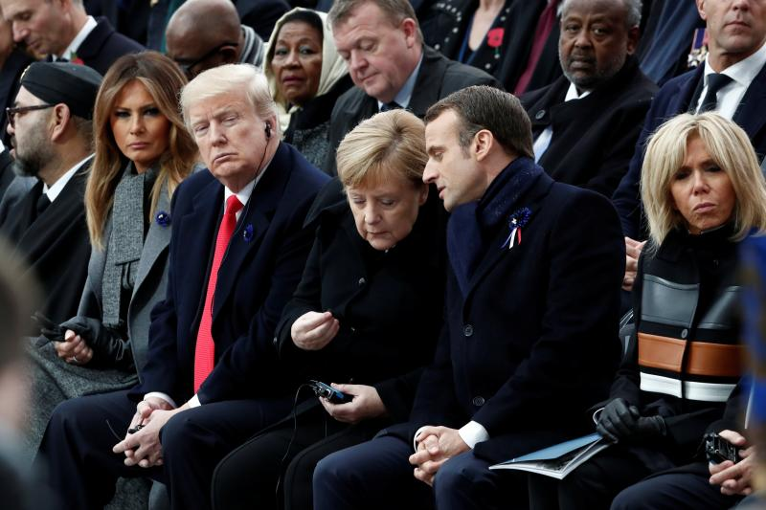
Trump, Merkel, and Macron at a commemoration ceremony for Armistice Day, 100 years after the end ofWorld War I, Paris, November 2018
Benoit Tessier / REUTERS
The Atlantic alliance as we know it is dead. The end of the Cold War, the United States’ growing weariness of global burdens, and a preoccupation with domestic affairs on both sides of the ocean had already weakened transatlantic bonds when the presidency of Donald Trump inflicted the deathblow.
A future U.S. administration, even one that is more sympathetic to the idea of alliances, will be unable to restore the old alliance. If a new alliance is to emerge from the ashes of the past, it must be one based on a more realistic bargain between Europe and the United States, and one that better addresses the needs of both partners. The alliance is dead; long live the alliance.

AUTOPSY
The alliance died slowly, then all at once. For the first two years of Trump’s presidency, European leaders behaved like abused spouses, mistreated but afraid to leave, hoping against hope that things would improve. Faced with overwhelming evidence that Trump did not believe in the concept of alliances and viewed Europe more as a rival than a partner, they clung to the vain hope that the “adults in the room”—the experienced foreign policy advisers around Trump—would restrain the president’s worst instincts. Some Americans buttressed this fantasy by imploring Europeans to pay more attention to Trump’s policies than his tweets and to take comfort in the president’s reassuring personnel choices, particularly that of Secretary of Defense James Mattis.
There will be no transatlantic alliance under Trump.
To keep Trump on side, European leaders flattered him. British Prime Minister Theresa May held his hand and offered him a state visit. French President Emmanuel Macron pretended to be his best friend and invited him to a big military parade in Paris. German Chancellor Angela Merkel held firm on values but studiously avoided policy disputes. The President of the European Commission Jean-Claude Juncker came to Washington and helped create the appearance of a trade victory for Trump without making any real commitments. None of these approaches worked. Flattering Trump bought only a momentary respite; his determination to stop letting Europe “take advantage of the United States” was implacable.
The European fantasy held—more or less—for Trump’s first two years, but reality is now setting in. There will be no transatlantic alliance under Trump. Having watched Trump in action, only 27 percent of people in the United Kingdom, ten percent in Germany, nine percent in France, and seven percent in Spain have confidence in the U.S. president to do the right thing when it comes to global affairs. Majorities in France and Germany trust China and Russia more than they do the United States and favorable views of the United States are down by double digits across the continent. Even Atlanticist leaders such as Merkel have concluded that Europe “must take its destiny in its own hands,” although neither she nor anyone else has yet figured out what that would entail.
Trump’s policies could scarcely have been better designed to undermine the alliance had that been their objective. Trump started off his presidency by abandoning the Paris climate pact, signaling that the United States would refuse to cooperate on an issue that most Europeans see as an existential threat. He then made a habit of questioning NATO’s Article 5 guarantee of mutual defense, the central pillar of European security for the past 70 years. The United States, he has declared, might not defend European allies that refuse to “pay their bills.”
In May 2018, Trump pulled the United States out of the Iran nuclear deal. Every country in Europe wanted to preserve it. Those that co-negotiated the deal—France, Germany, the United Kingdom, and the EU—bent over backwards to meet Trump’s demands that the arrangement be “fixed.” But after months of negotiations, Trump pulled the plug anyway, threatening the United States’ closest trading partners with sanctions. Later in May, Trump announced tariffs on European steel and aluminum. He has threatened to impose similar taxes on automobile imports, under the absurd pretext of the need to defend “national security,” a threat that prompted Merkel to remind him last week that many of the German cars Americans buy are built in South Carolina.
In December, Trump sent Secretary of State Mike Pompeo to Brussels to deliver a withering assault on the very concept of multilateralism. Speaking in the EU capital, Pompeo excluded the EU from the short list of multilateral organizations the United States considered effective, invoked Brexit as a healthy “wake-up call” for the bloc, and implied that “bureaucrats in Brussels” put their own interests ahead of those of their countries and citizens. Trying to put an intellectual framework around Trump’s aggressive nationalism, Pompeo asserted the “central role of the nation-state” and maintained that the United States’ mission was to “reassert our sovereignty.” Essentially declaring America’s intention to act however it saw fit, and reminding his audience of principles that, when abused, once left their continent in flames was an odd way to rally European support for the “central leadership role in the world” to which he said the Trump administration was returning.
A few weeks later, as if to demonstrate what his version of sovereignty looked like, Trump suddenly announced plans to withdraw all U.S. troops from Syria without consulting or even informing the United States’ European partners in the fight against the Islamic State (or ISIS). This sudden move took even Trump’s top officials by surprise. But that did not prevent those same officials from later requesting that European countries replace U.S. forces and that they accept detained ISIS fighters whom the United States would not take. Last week Trump reversed course yet again, saying some U.S. troops would remain, but Europeans remain wary of joining them, unsure what the next tweet might say. With such a confrontational, unreliable, and unpredictable partner in Washington, the question should not be why Europeans are now turning away from the United States but why it took them so long to do so.
To be fair, Trump has maintained and even increased some elements of transatlantic cooperation. He implemented President Barack Obama’s decision to deploy more U.S. defense assets to Eastern Europe, sent arms to Ukraine, and signed—grudgingly—legislation sanctioning Russia for interfering in U.S. elections and trying to assassinate a former spy in the United Kingdom. But these were all rearguard actions, engineered, sometimes against Trump’s will, either by Congress or by people no longer in the administration. Now, having lost his majority in Congress and turning to foreign policy for political victories, as many presidents have before him, Trump is acting more in line with his own instincts. That is bad news for Europe.
The “adults in the room” are gone, too. Rex Tillerson, the former secretary of state, H. R. McMaster, the former national security adviser, James Mattis, the former secretary of defense, and John Kelly, the former chief of staff, all had a traditional view of alliances and tried to show a degree of independence from the president; all have been forced out of the administration. In a stunning rebuke of Trump’s world view, Mattis’ resignation letter underlined the importance of “treating allies with respect” and Mattis’ conviction, obviously not shared by the president, that “our strength as a nation is inextricably linked to the strength of our unique and comprehensive system of alliances and partnerships.”
With the departure of those officials, Trump is now surrounded by people, such as national security adviser John Bolton, who either share his preference for unilateralism or are willing to bury their own views to please their boss. Vice President Mike Pence’s obsequious praise for Trump—a “champion of freedom,” apparently—in a speech at the Munich Security Conference in February seemed to be aimed at an audience of one. And his expectation that an audience largely made up of Europeans would applaud at the mention of “the 45th President of the United States” suggests that the administration is oblivious to the damage it has done.
Pompeo, in turn, had to swallow hard and defend Trump’s decision to pull U.S. troops out of Syria (a “change of tactics but not of strategy”) as well as Trump’s unwillingness to confirm that the United States would automatically come to the defense of NATO allies. When asked in January if the United States would uphold Article 5 for NATO member Montenegro, Pompeo refused to “get into hypotheticals.” The United States’ European allies previously believed that a U.S. treaty commitment was not hypothetical—indeed, the guarantee was created to deter aggression by taking the ambiguity away.

THE ALLIANCE IS DEAD
The United States and Europe have clashed before. Indeed, the history of the alliance is a history of splits. In 1956, during the Suez Crisis, the United States deliberately undermined a war that France and the United Kingdom had started. In Vietnam, European countries refused to support an American war. During the presidency of Ronald Reagan, Europe and the United States argued over gas pipelines from Russia and U.S. missiles in Europe. During the Clinton administration, Americans and Europeans fought about trade, and about U.S. sanctions on European business with Cuba, Iran, and Libya. The George W. Bush administration pursued policies on Iraq, missile defense, and climate change, provoking European critiques similar to those made of the Trump administration today.
Yet there is something fundamentally different about the current crisis. This is not merely due to the absence of a shared threat from the Soviet Union. Whatever their differences with Europe, all previous U.S. presidents, Democrat and Republican alike, believed that the alliance with Europe mattered. Americans valued European support.
This president is different. He doesn’t believe in alliances, treaty commitments, loyalty, or the value of European partners. For the Trump administration, U.S. “leadership” means the United States doing what it wants, and transatlantic “unity” means Europeans doing what the United States tells them to do. During Bush’s second term, after the Iraq disaster, the United States returned to a more multilateral approach, in part out of a recognition that it had to keep the Europeans on board and in part to spur Europe to contribute more to U.S. efforts. There will be no similar pivot under Trump. On the contrary, Europeans will realize they have to rely more on themselves, as Merkel and others have said. Such a “Europe first” policy, whether in the form of trade retaliation, independent energy initiatives such as the Nordstream 2 pipeline with Russia, financial instruments created to avoid U.S. sanctions, or joint efforts with China to counter the United States in international forums, will only exacerbate tensions with Washington.

LONG LIVE THE ALLIANCE
So, is the transatlantic breach permanent? Not necessarily. The old relationship is dead, but a new one can emerge. Trump has his fervent supporters, but many in the United States still recognize the importance of allies. According to recent polls taken by the Chicago Council on Global Affairs, 91 percent of Americans say the United States is more effective when it works with allies, and the share of Americans who support an “active U.S. role in world affairs” has actually risen under Trump, from 63 to 70 percent. Seventy-three percent of Americans believe it is more important to be admired in the world than feared. Solid majorities want the United States to participate in the Paris Climate accord (68 percent) and the Iran nuclear deal (66 percent), and 75 percent want to see the United States maintain or increase its commitment to NATO. In part as a result, all the major Democratic candidates in the coming presidential election will run on restoring alliances and adopting policies that align with European preferences on issues such as Iran, climate change, and arms control.
That said, Europeans cannot just wait Trump out. He could win in 2020, and if he does, the alliance could be reborn as a populist, nationalist, and racist partnership between the United States and governments in Hungary, Poland, Italy, or others. Such a transatlantic alliance, one based on the shared values of hating Islam and immigrants, would not be worth having.
Even if a Democrat wins in 2020 there will be no going back to the way things were. A Democratic president will be more positively disposed toward cooperation with Europe, but deeper trends will continue to make the United States a demanding partner. Declining U.S. relative power, the accumulating costs of military deployments, and competition with China and other powers will increasingly challenge the American public’s willingness to bear the burdens of global leadership.
Trump’s policy toward Europe was in this sense a symptom, if an extreme one, of a deeper disease. No future U.S. president will be elected on a mandate of solidarity with Europe without being assured of getting something in return. The next U.S. president will probably take a tough line on trade and focus more on Asia and Latin America than on Europe. The United States need not become the angry, xenophobic bully of Europe’s worst fears, but neither will it be the transatlantic altruist of Europe’s nostalgic fantasies.
A new transatlantic alliance will require both a U.S. president who recognizes its value and Europeans who are able to overcome their own internal divisions and commit to an equal partnership. The next alliance cannot be only about channeling U.S. contributions to European security; it must also be a global partnership to which each side contributes in order to protect their mutual security and economic interests. That sort of alliance remains possible. It is worth fighting for.

