Pompeo Speech Lays Out Mideast Manifesto, Taking Shots at Obama
By Declan Walsh and David E. Sanger
https://www.nytimes.com/2019/01/10/world/middleeast/mike-pompeo-speech-middle-east-obama.html?action=click&module=Top%20Stories&pgtype=Homepage

- Jan. 10, 2019
CAIRO — Secretary of State Mike Pompeo laid out a new manifesto for American action in the Middle East on Thursday, telling a university audience here that “the age of self-inflicted American shame is over” and that the United States would take a far more activist role in the region, despite fears that President Trump’s decision to pull troops out of Syria marks a new phase of withdrawal.
Mr. Pompeo delivered a scathing — and quite personal — rejection of President Barack Obama’s approach to the Middle East, excoriating Mr. Obama for “fundamental misunderstandings” about the region that “underestimated the tenacity and viciousness of radical Islamism.”
And he described a policy of containment of Iran’s power, pressing for allies in the region to isolate the country. He vowed to “expel every last Iranian boot” from Syria, but offered no plan to achieve that goal at a moment that the small American force of 2,000 troops is scheduled to get out.
The seeming contradiction between Mr. Trump’s impulsive announcement that United States forces would leave Syria and Mr. Pompeo’s declaration that “when America retreats, chaos follows” confounded many in the region. They say they cannot reconcile the declaration with the president’s Dec. 19 tweet that his only reason for remaining in Syria was the defeat of the Islamic State, a job he said had been completed.
ADVERTISEMENT
Only three months ago, Mr. Trump’s national security adviser, John R. Bolton, promised that American forces would not leave Syria until the Iranians were out of the country.
So far in Mr. Pompeo’s nine-nation tour of the region that started Tuesday, he has had to reassure jittery nations who have interpreted the president’s instincts as the definition of retreat. Mr. Pompeo spent much of the day in Cairo trying to explain the new strategy, arguing that it does not take troops on the ground to influence events.
Mr. Pompeo picked the timing and locale of his speech for dramatic effect: It was almost exactly a decade after Mr. Obama delivered a landmark speech at another university in Cairo, offering an olive branch to Iran and urging autocrats to permit greater freedoms.
American troops outside the northern Syrian city of Manbij in February 2018.CreditMauricio Lima for The New York Times
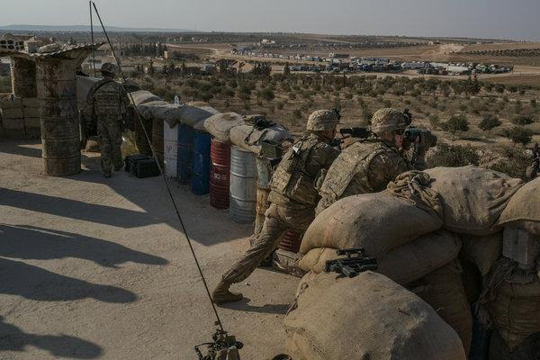
I
American troops outside the northern Syrian city of Manbij in February 2018.CreditMauricio Lima for The New York Times
Mr. Obama later conceded that his administration had done a poor job of turning the lofty rhetoric of that speech into action on the ground. And much of his strategy was swept away in the 2011 Arab spring, with the upheavals it brought to the region.
Mr. Pompeo offered his own reset, based on unquestioned American leadership and an alliance of Arab authoritarians to counter Iran, without dwelling at all on human rights issues. The word “rights” does not appear in Mr. Pompeo’s text.
ADVERTISEMENT
Iran immediately rejected the speech.
“Whenever/wherever U.S. interferes, chaos, repression and resentment follow,” the Iranian foreign minister, Mohammad Javad Zarif, posted on Twitter hours after Mr. Pompeo spoke. “The day Iran mimics U.S. clients & @SecPompeo’s ‘human rights models’ — be it the Shah or current butchers — to become a ‘normal’ country is the day hell freezes over.”
Mr. Pompeo’s assertion of American purpose in the Middle East comes at a moment when Washington’s will to lead has been widely questioned.
The decision to withdraw from Syria has created a diplomatic tangle with Turkey and, since the resignation of Defense Secretary Jim Mattis over the Syria announcement, has led to fears among allies that Mr. Trump is not on the same page as his national security team.
While Mr. Obama spoke with the air of the professor he once was, Mr. Pompeo stressed his military background, Christian faith and fondness for plain speaking. “It is a truth that isn’t often spoken in this part of the world, but I’m a military man by training, so I’ll put it bluntly: America is a force for good in the Middle East. Period.”
Mr. Obama’s era was time of disastrous misjudgments, he said. “What did we learn from all this?” he said. “When America retreats, chaos follows. When we neglect our friends, resentment builds. When we partner with enemies, they advance.”
Former Obama officials sprang to defend their legacy.
“Listening to Secretary Pompeo’s speech is like listening to someone from a parallel universe,” said Robert Malley, Mr. Obama’s coordinator for the Middle East. He called the speech “a self-congratulatory, delusional depiction of the Trump administration’s Middle East policy.”

Editors’ Picks

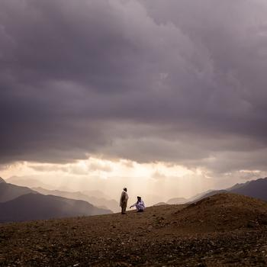

C.I.A.’s Afghan Forces Leave a Trail of Abuse and Anger

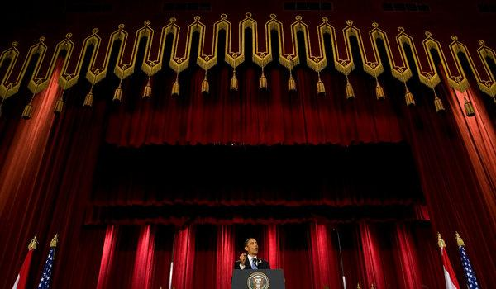

President Barack Obama delivered a much different message at Cairo University in 2009.CreditStephen Crowley/The New York Times

Jeffrey Prescott of National Security Action, a group led by former Obama officials, said it showcased the Trump administration’s obsession with Iran and with Mr. Obama. “Pompeo sees his audience as the region’s autocrats rather than its people,” he said.
ADVERTISEMENT
The speech met with polite applause from a selected audience at the American University in Cairo. But it will be warmly welcomed by autocrats like President Abdel Fattah el-Sisi of Egypt, who met with Mr. Pompeo earlier Thursday.
Mr. Pompeo made no direct reference to rampant human rights abuses in Egypt under Mr. Sisi, or to the estimated 60,000 political opponents human rights groups say are languishing in Egyptian jails.
There was a one-line reference to Yemen, where the Saudi crown prince, Mohammed bin Salman, has spearheaded a ruinous war that has driven the country to the brink of famine. He made only a single reference to the Palestinians, but repeatedly stressed America’s ties to Israel and the threats it faced.
Where Mr. Pompeo found hope in the region, it was mostly in closer links between American allies, or in overtures to Christians.
“Who could’ve believed a few years ago that an Israeli prime minister would visit Muscat?” he said. “Or that a Roman Catholic pope would visit this city to meet with Muslim imams and the head of the Coptic faith?”
An Israeli minister cried, he said, after the Israeli national anthem was played at a sports tournament in the United Arab Emirates. “She could not have been happier,” he said.
After the speech, Mr. Pompeo drove out to a soaring new Coptic cathedral at the New Administrative Capital, a signature project of Mr. Sisi that is under construction 30 miles east of Cairo, in the desert.
.

